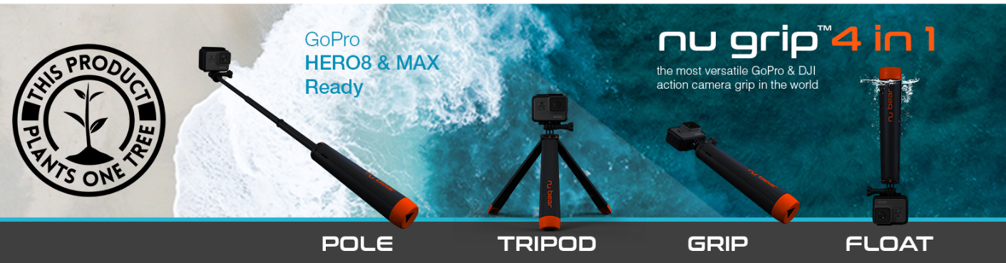
Press Release:
The World’s First 4 in 1 Floating Tripod Grip: Live on Indiegogo
Launched on Indiegogo: London, United Kingdom, 01/07/2020

4 Key Functions in 1: Float - Grip - Pole - Tripod

- Nu Grip floats allowing you a chance to let go and enjoy time underwater. Nu Grip can float in either grip or tripod mode.

- It’s a versatile Grip weighing only 140g (4.9 oz.), the ultimate lightweight travel companion.

- All you need is a quick twist, extend and lock, to access the 22.25 inches / 56.5cm pole. Nu Grip collapses down to a 9 inch / 23cm grip.
- Use Nu Grip as a tripod, the full-size legs offer excellent stability and the rubber feet give extra grip on slippery surfaces.
Nu Grip will retail for £59.99 ($75) however it will be available on Indiegogo from £46/$57. One tree will be planted for every Nu Grip backer as part of our partnership with the One Tree Planted organisation.

The world’s first 4-in-1 action camera grip is set to start rolling off the production lines this month after it smashed its crowdfunding target in less than 24 hours.

Nu Grip 4in1, designed and created by a team of London-based entrepreneurs, is the first extendable floating tripod on the market, and launched on Indiegogo this week.

With 29 days left to go, Nu Grip has reached 250% of its fundraising target, with orders rolling in from over 42 countries across the world including the US, Italy, Taiwan, Japan, Australia and Dubai.

It already has received rave reviews from industry experts, including Mitch Bergsma, Photographer and YouTuber (https://www.instagram.com/micbergsma/) who said “It is literally the only pole you will ever need!” and David Manning, Photographer and YouTuber (https://youtu.be/xKMyjEb3i_Y) who called it “His favourite new GoPro accessory!”

Nu Grip is quick to set-up, with a simple twist and pull it transforms from a 9-inch (23cm) grip to a 22.25 inch (56.5cm) pole. The versatile grip quickly folds out to a stable tripod and innovatively it floats in water.

Nu Grip is easy to carry around, being the lightest of its kind at 140g (4.9 oz.) and it fits snuggly in the pocket of a bag. The buoyant bright tripod legs float at the surface, allowing adventurers to capture underwater moments, without the fear of losing their camera.

Designed with GoPro and DJI in mind, Nu Grip has been float tested around the world with over 25 different models of action camera, and will appeal to photography enthusiasts and professionals as well as first-time users.

Basmah Jolley, Creative Director/Co-founder, said: “We are so pleased that so many camera enthusiasts from around the world are as excited about this product as we are. We really felt the need for a 4-in-1 grip when we took our action camera on our travels, and it’s great to hear so many people say that they have also been waiting for a product like this. ”

“We have already developed the manufacturing process and production has now begun. We can’t wait to see people using Nu Grip, and we’re really looking forward to seeing all the pictures and videos Nu Grip users across the world take with their action cameras and mobile phones.”

Nu Grip, with patent-pending design, is the first product launched by Nu Bear, an adventure and travel product design company from husband-and-wife team Richard and Basmah Jolley. The couple met when they were both studying Industrial Design at Loughborough University, and have spent their entire careers in design before setting up Nu Bear. Basmah has worked in set design for Film and TV and was part of the team behind the London 2012 Olympic Opening and Closing Ceremonies.

Richard has spent many years designing aircraft interiors for both luxury and commercial airlines and he has built a reputation for delivering conceptual design right through to viable working products. Richard left his full-time job to focus on Nu Bear.

They both love to travel but are conscious of the impact that tourism has on the planet, so sustainability is at the heart of Nu Bear’s company philosophy. Nu Grip has been designed with this in mind and the product and its packaging are completely recyclable.

Basmah Jolley, Creative Director/Co-founder, said: “We love photographing the beautiful marine life of the ocean. However, there is a huge problem globally of the human impact on the ocean’s eco systems and the harmful effects of plastic pollution. The appreciation of nature is a crucial part of Nu Bear’s company philosophy and we are dedicated to engaging in an environmentally friendly packaging production process, with no single-use plastics. All our components are fully recyclable, and we are minimising energy use from initial creation through to shipping, as well as looking into advising customers on the best recycling options further down the line.”

Richard Jolley, Managing Director /Co-founder, said: “Of course there is always more that we can do, so we will constantly look at improving our design and manufacturing processes to minimise the environmental footprint. We have partnered with One Tree Planted an organisation focused on reforestation and shall be planting one tree for every Nu Grip reward on our campaign.”

The couple came up with the idea for Nu Grip whilst travelling in South East Asia with a new GoPro. At the time there were many accessories to choose from, but they needed three or four different types, and they were expensive.

Basmah Jolley said: “We thought it would be a good idea if we could have one grip that would combine all the functions and be affordable. The idea of one camera and one grip was very attractive when planning weekends away and to minimise the number of accessories on more adventurous trips.”

“So with our backgrounds in design we embarked on turning the idea into a product and have spent the last 18 months designing, prototyping, testing and developing the 4 in 1 solution that is Nu Grip.”

Richard Jolley said: “Whether you are snorkelling with Manta Ray, snowboarding down a mountain or sailing in a Summer breeze, Nu Grip has been designed to be the perfect travel companion. No need to pack lots of accessories, this 4 in 1 grip will be the perfect partner for your camera on any adventure.”

Nu Grip is further along in the process than most Indiegogo campaigns. In their commitment and confidence in the product, Nu Bear have gone beyond initial product prototypes and testing and have developed the production tooling and process for manufacture. They have travelled to Asia to refine the manufacturing process and have a strong relationship with their supplier. Since securing their funding target they have hit the button to commence production already, minimising the risk of long delays.

Following the Indiegogo campaign, http://igg.me/at/NuGrip4in1 Nu Grip will be available for purchase online at https://www.nu-bear.com and through major retailers.

ENDS

Note to Editors
About Nu Bear
Founded in London Paddington in 2017 by husband and wife, Richard and Basmah Jolley. Nu Bear is a design company bringing innovation to the travel accessory market. They also design for the aerospace industry, feature film and live events. Nu Bear have spent the last 18 months designing, testing and preparing Nu Grip ready for production.
The Indiegogo campaign runs for 30 days until 30/07/2020
E: Marketing@nu-bear.com
E. design@nu-bear.com
T: 0044 (0) 7843605182

Indiegogo Project Page link: http://igg.me/at/NuGrip4in1
Website: http://www.nu-bear.com/
Media Kit on Dropbox: https://bit.ly/3dV9eIJ
Instagram: https://www.instagram.com/nu_bear/
Facebook: https://www.facebook.com/NU.BEAR.DESIGN/
Media Kit on Website: https://www.nu-bear.com/media

